**- short title/desc for artwork**

1. Pontianak Batik

Description:

Created digitally on an A3 canvas, this piece blends traditional Malaysian batik motifs with horror urban legends from my childhood. It merges cultural aesthetics and eerie storytelling, exploring the tension between beauty and unease through intricate patterns and unsettling imagery.

2. Dance Macabre

Description:

A cheeky digital piece exploring body image and identity through bold colours, camp aesthetics, and a skeleton rocking a glossy dress with confidence.

3. Pawana Mairat Character Design

Description:

A character turnaround sheet I’ve made for my Character and Layout Design class under Sir Zaky. Pawana Mairat is a creative take on a Nusantara version of Deathstroke from DC Comics

Description:

A semi realistic portrait art of my original character Hellena, highly inspired by an artist from Instagram that goes by Jettienet. She was also Inspired by NewDad’s album cover for ‘Madra’.

5. Obscura Poster

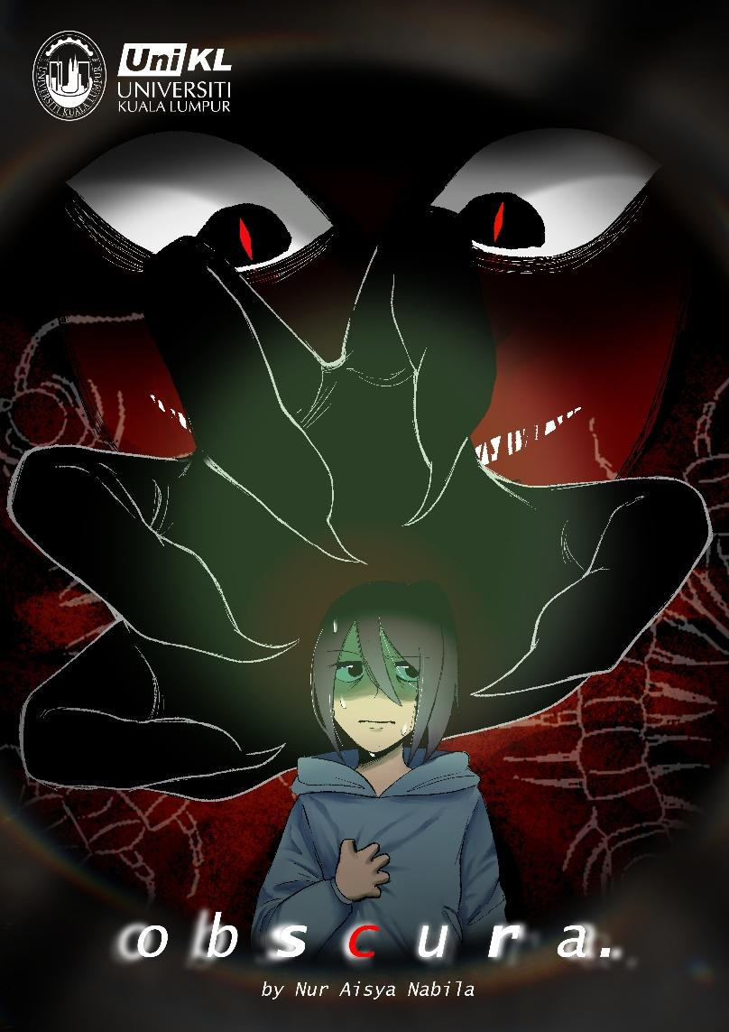

Description:

Poster of my Final Year Project featuring the main character of Obscura, a 3 minute long 2D animation solo project.

**- 1 favorite quote**

Everythings gnarly…!

**- short bio (50-150 words max)**

24-year-old artist with ADHD, living for bizarre creatures and weird art. Kafka gets me (because who hasn’t felt like a giant bug, right?). When I’m not sketching, you’ll catch me diving into true crime podcasts, geeking out over Sonic, or switching things up with some cosplay. Sharp mind, sharp lines, and all about finding beauty in the obscurity.

**- socmed handle or email**

Instagram: @heyradmille

Email: aradmille@gmail.com